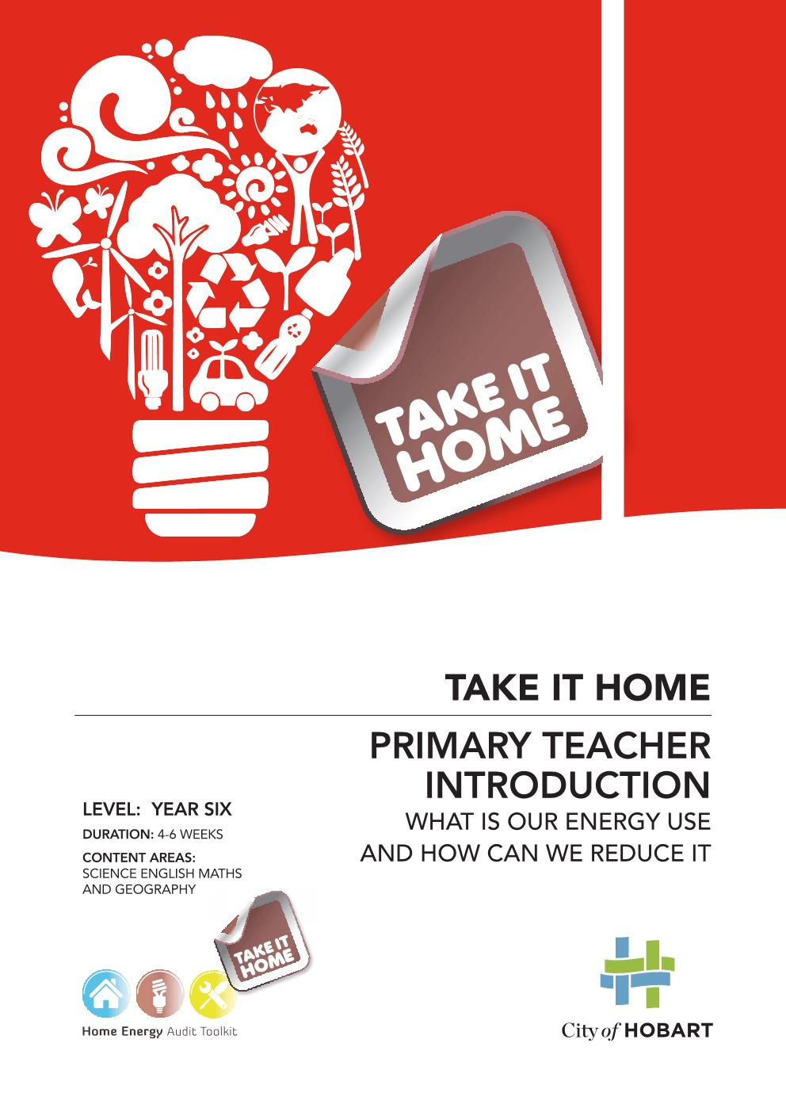
Take it Home – primary

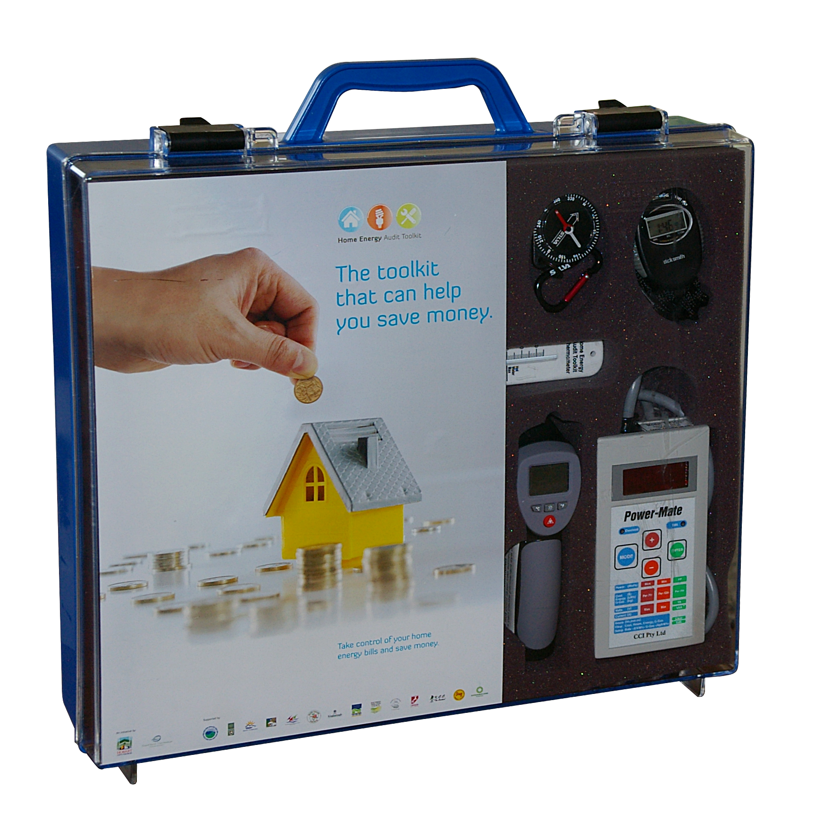
This resource provides two sets of activities designed to help year six students develop an awareness of energy consumption in the home and at school.
Through a range of hands-on activities, students investigate how energy is used and look for clues on how it is being wasted and then plan and take action in practical ways to save energy.
The ‘Take it Home’ primary program aligns with the Year Six Australian Curriculum and embeds learning about sustainable lifestyles, energy efficiency and the reduction of greenhouse gases. It was developed by the Snug Primary School through a Tasmanian Climate Connect grant in collaboration with City of Hobart and Kingborough Council. The City of Hobart then collaborated with New Town High School to develop teaching materials for secondary students. The City has been able to bring the two projects together to create a resource that can be used by schools across southern Tasmania.
The activities are based on the City of Hobart’s ‘Home Energy Audit Toolkit,’ which can be borrowed in class sets at no cost from the City of Hobart.
The program resources and materials are hosted on the City of Hobart website: hobartcity.com.au/Environment/Home_Energy_Audit_Toolkit_HEAT.
The ‘Take it Home’ primary program develops the following skills:
- reading a power meter;
- identifying energy outputs;
- reading energy ratings of appliances;
- determining the effectiveness of insulation;
- recommending and implementing energy savings at school and at home;
- developing proficiency in safely and effectively using the Home Energy Audit Tool kit;
- teaching these skills to family members and other students;
- developing energy efficiency plans for school and home;
- undertaking an energy assessment; and
- identifying energy efficient light bulbs.

Year Six Australian Curriculum alignment
Science
Content Description | Elaboration
Science Understanding: Chemical Science | (ACSSU095) Changes to materials can be reversible or irreversible
Physical Sciences | (ACSSU097) Electrical energy can be transferred and transformed in electrical circuits and can be generated from a range of sources
Science as a Human Endeavour: Use and Influence of Science | (ACSHE100) Scientific knowledge is used to solve problems and inform personal and community decisions
Science Inquiry Skills: Planning and Conducting | (ACSIS103) Identify, plan and apply the elements of scientific investigations to answer questions and solve problems using equipment and materials safely and identifying potential risks
English
Content Description | Elaboration
Literacy:  Interacting with Others | (ACELY1709) Participate in and contribute to discussions, clarifying and interrogating ideas, developing and supporting arguments, sharing and evaluating information, experiences and opinions  (ACELY1816) Use interaction skills, varying conventions of spoken interactions such as voice volume, tone, pitch and pace, according to group size, formality of interaction and needs and expertise of the audience  (ACELY1710) Plan, rehearse and deliver presentations, selecting and sequencing appropriate content and multimodal elements for defined audiences and purposes, making appropriate choices for modality and emphasis
Literacy: Interpreting, Analysing and Evaluating | (ACELY1712) Select, navigate and read texts for a range of purposes, applying appropriate text processing strategies and interpreting structural features, for example table of contents, glossary, chapters, headings and subheadings  (ACELY1713) Use comprehension strategies to interpret and analyse information and ideas, comparing content from a variety of textual sources including media and digital texts

Mathematics
Content Description | Elaboration
Number and Algebra: Number and Place Value | (ACMNA123) Select and apply efficient mental and written strategies and appropriate digital technologies to solve problems involving all four operations with whole numbers
Number and Algebra: Fractions and Decimals | (ACMNA128) Add and subtract decimals, with and without digital technologies, and use estimation and rounding to check the reasonableness of answers  (ACMNA129) Multiply decimals by whole numbers and perform divisions by non-zero whole numbers where the results are terminating decimals, with and without digital technologies
Statistics and Probability: Data representation and Interpretation | (ACMSP147) Interpret and compare a range of data displays, including side-by-side column graphs for two categorical variables  (ACMSP148) Interpret secondary data presented in digital media and elsewhere
Geography
Content Description | Elaboration
Geographical Inquiry and Skills Questioning | (ACHASSI122) - Develop appropriate questions to guide an inquiry about people, events, developments, places, systems and challenges
Geographical Inquiry and Skills Analysing | (ACHASSI127) Examine different viewpoints on actions, events, issues and phenomena in the past and present

Sample letter to encourage family participation
Date:
Dear Parents / Carers,
Grade 6 students are undertaking a five week unit called Take It Home to learn about energy use at school and home. This unit helps students develop skills to understand how energy efficiency can improve comfort levels, reduce costs and lessen environmental impacts.
In this unit students will investigate classroom and home energy consumption using the Home Energy Audit Toolkit (HEAT). The HEAT Kit includes measuring tools such as a Power-Mate to measure the energy consumption of appliances. A radiometer will be used to measure the temperature differences in the ceiling.
The chart shows the typical power consumption in a Tasmanian home.
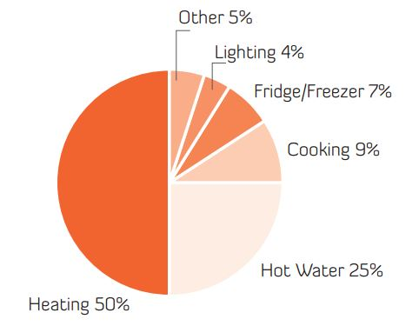

Students will be asked to measure energy consumption in the home and bring the
data to school.
Students will investigate opportunities to reduce their energy use with the support of members of the school community and their family.
Ten HEAT Kits have been hired by the school for the students to use throughout this unit.
When the kits come home to your house, please ensure that they are well cared for.
We look forward to your support in this partnership.
Yours sincerely
Principal
Glossary of words used in this resource
Action plan - A list of activities to deal with a problem.
Adaptation - Actions to cope with a changing environment. For example with predicted sea level rise Council planning laws may restrict building on low lying land.
Air pollution - Chemical, biological or particulate matter that changes the atmosphere. Two examples of harmful air pollution are car exhausts emitting carbon monoxide and coal burning producing sulphur dioxide.
Atmosphere - The mixture of gases surrounding the Earth and any star or planet.
Carbon dioxide - A colourless odourless gas formed by the burning of carbon compounds or breathed out by animals. The burning of fossil fuels (oil, coal and natural gas) to create electricity and produce fuel for transport is increasing the amount of carbon dioxide (CO₂) in the atmosphere.
Carbon Pollution - Too much carbon dioxide in the atmosphere from the burning of fossil fuels causing the planet to warm.
Climate - The long-term average weather pattern of a region.
Climate Change - Long term change to the climate such as global warming.
Electrical energy - The flow of charged particles called electrons or ions.
Emissions - Sending gases out into the atmosphere.
Energy - The ability to do work.
Energy audit - Collecting and interpreting information about energy use in a building and developing ideas about reducing energy consumption.
Energy consumption - The amount of energy (gas or electricity) used over a period of time. Usually measured in kilowatt hours (kWh)
Fossil fuels - Oil coal and natural gas made deep within the earth from the remains of ancient animals and plants over millions of years. They provide most of the world’s energy (including transport and electricity). They are non-renewable and there is less and less oil available.
Greenhouse effect - The carbon pollution has built up into a heavy layer in the atmosphere that doesn't let the heat out.
Greenhouse gases - Greenhouse gases work like a blanket keeping you warm on a cold night - too thick and you overheat. Carbon dioxide, methane and water vapour are the most common of the 30 greenhouse gases.
Global warming - The warming of Earth’s surface through an increase of greenhouse gases in the atmosphere.
Heat pump - A heater that extracts heat from a low temperature environment and transfers the energy to a high temperature environment. The technology is used for water heating and air conditioning.
Incandescent bulb - Standard low-efficiency electric light bulb.
Kilowatts kWh - Equals 1000 watts of electricity. When you are billed for 1kWh of electricity consumption, that means you used 1kW (=1000 watts) of electricity for one hour (eg. you left ten 100W light bulbs on for an hour).
Methane (CH4) - A naturally occurring gas formed by bacteria that break down organic matter. The main sources of methane are the digestive processes of livestock, the cultivation of rice, escaping natural gas and decomposing waste in garbage dumps or landfills and volcanic and geothermal activity.
Non-renewable energy - A non-renewable resource is a natural resource such as coal or gas which cannot be produced, re-grown, regenerated, or reused.
Ozone layer - A layer in Earth's atmosphere which contains relatively high concentrations of ozone (O₃). This layer, approximately 13 km to 40 km above the Earth, absorbs 97–99% of the Sun's high frequency ultraviolet light, which is damaging to life on Earth.
Pollution - Harmful substances in the air, water or soil created by people.
Power - Is the rate at which work is done or energy is used. Power is force x speed.
Renewable energy - Is any type of energy generated from natural resources that is infinite or constantly renewed such as solar, wind and hydropower.
R factor - Is a measure of how well insulation material stops heat penetrating.
Solar panel or photovoltaic cell (PV) - Is a system that converts light into an electric current.
Sustainability - Is the ability to keep going.
Standby power - Refers to the power used by electronic appliances while they are switched off or in a standby mode. If an appliance has a standby light or clock this shows it is in standby mode.
Stationary energy - Energy used to heat, cool and light our houses, offices and buildings.
Watts - The amount of power an electrical appliance uses. The size of the hole in the wire is the "amps", the amount of pressure behind the wire is the "volts", and the combination of how much energy comes out at a given pressure is "watts", or power - the measure of how much work can be done. When you are billed for 1kWh of electricity consumption, that means you used 1kW (=1000 watts) of electricity for one hour (eg. Ten 100W light bulbs turned on for an hour).
Weather - The state of the air, such as hot or cold, wet or dry, calm or stormy, clear or cloudy. We can have hot, warm or cold weather, and windy, wet or dry weather.
Reference: Carbon Kids, ACT Department of Territory and Municipal Services, Educating for Sustainability through the ACT Curriculum – Climate Change for a Sustainable Future, Canberra www.sustainableschools.act.gov.au

References and web sites
- The Tasmanian energy statistics are taken from this report – Economic Regulator Energy in Tasmania - Performance Report 2014-15
- The energy story- what is it? (http://www.energyquest.ca.gov/story/chapter02.html)
- Antarctic Climate & Ecosystems Cooperative Research Centre (http://acecrc.org.au)
- Colliver, A., Carbon Kids Resource Kit, CSIRO, 2010
- Department of Education, Energy Saving Guide for Tasmanian Government Schools, Department of Education. Tasmania
- Helen Cleugh, Mark Stafford Smith, Michael Battaglia, and Paul Graham. 2011. Climate Change: Science and Solutions for Australia. CSIRO PUBLISHING, 168 pp.
- Wright. J., Osman Peter and Ashworth, P., The CSIRO Home Energy Saving Handbook, How to save Energy, Save Money and Reduce your Carbon Footprint, 2009.
- Climate Change and Game-Based Learning (www.edutopia.org/blog/climate-change-and-gbl-matthew-farber)
- Source The CSIRO Energy Saving Handbook, CSIRO.

